Open City - by Community Advocates

*Transiting into the heart of commuters*

ECCE App Challenge 2019

Overview

The Open City app allows users to determine how accessible Calgary city services are to Calgary communities via public transportation.It allows citizens to better understand the services they have access to via direct transit routes, inspiring them to explore new communities within Calgary, and offering alternatives to driving to essential services.

Meet our Team

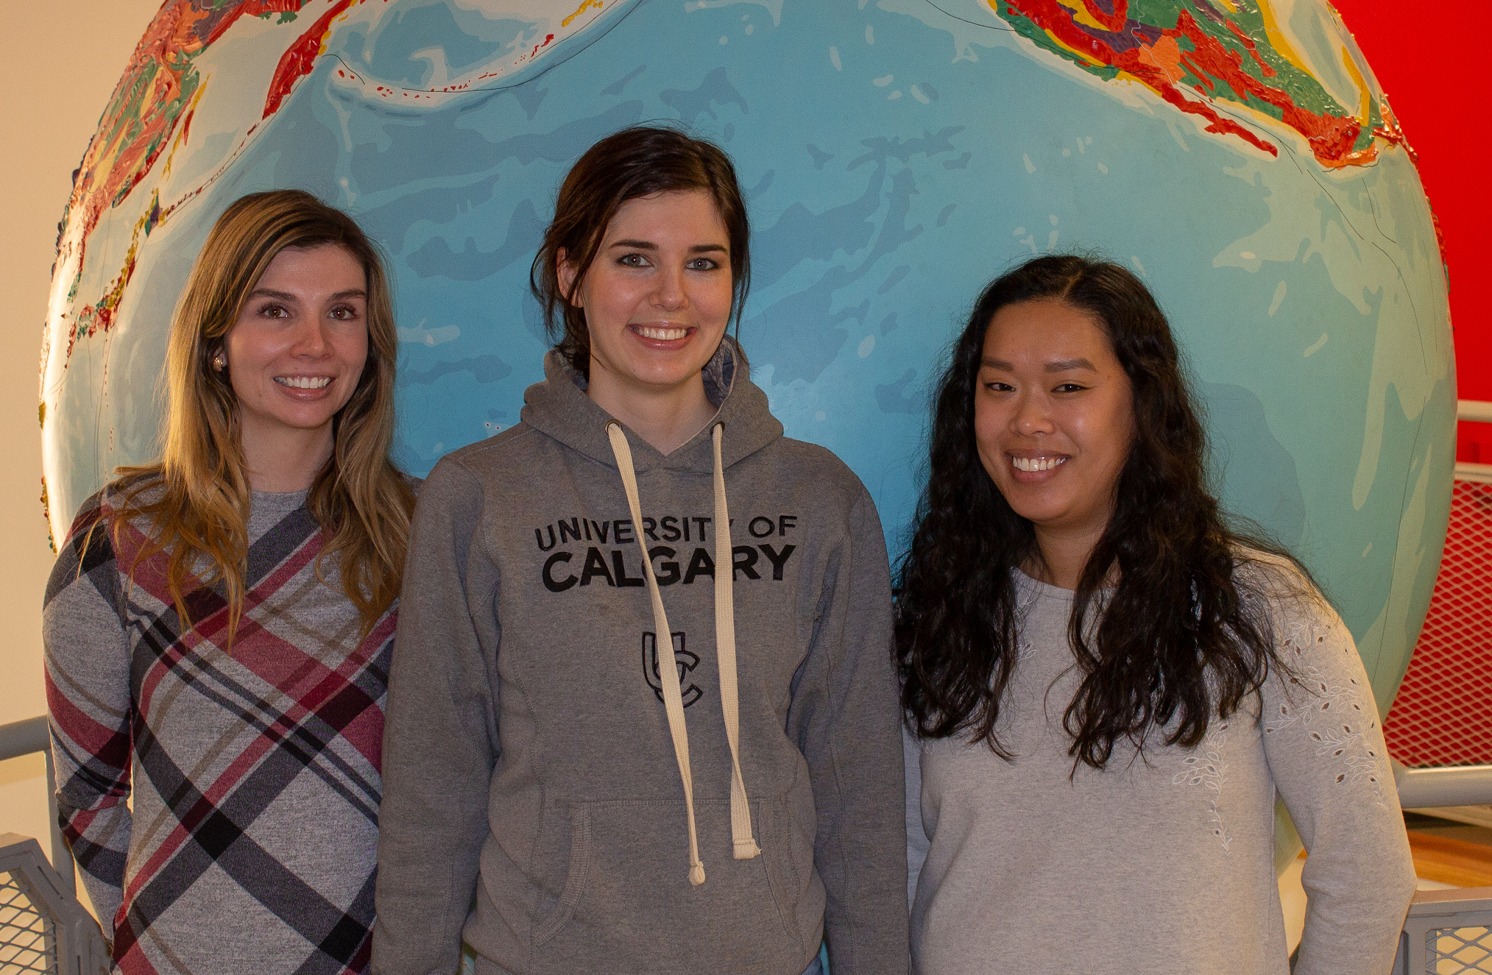

We are a group of passionate students, inspired by the challenge to improve the sustainability of our cities through Esri platforms. We learned so much creating this app, including the value of teamwork, and we had some fun too!

**Joyce Percel:** Joyce is a first year PhD student in the Department of Geography at the University of Calgary. Broadly, her research interests are Urban Geography, Critical GIS/Critical Data Studies, and Critical Race Theory. Her work focuses on analyzing how dominant ideas represented in data collection and visualization can impact the experiences of marginalized communities.

**Rachel Tessier:** Rachel is originally from Baton Rouge, Louisiana, and is currently in her first year of the MSc program at the University of Calgary where her research focuses on theoretical ecology. More specifically, her work involves conducting meta-analyses to determine the most effective statistical technique to detect unimodal shapes in data. She has her B.S. in Natural Resource Management and Ecology from Louisiana State University.

**Dylan Cunningham:** Dylan is a masters student at the University of Calgary where he is studying the spatial distribution and formation mechanisms behind a prairie groundwater discharge know as a ‘soap hole.’

He like rocks, maps, and water - In that order.

**Nikki Rogers:** Nikki is currently pursuing her Master's degree in Geographic Information Systems at the University of Calgary. She has a Bachelor's degree in Psychology, and a background in Health and Human Services, where she provided consultation on the collection, interpretation, and visualization of data. Her current research interests involve how to improve the inclusion of typically marginalized people in policy and planning decisions.

Mission Statement

Public transportation is essential to the sustainability of any city. It increases the mobility and freedom of citizens by enhancing access to the city as a whole, allowing people to venture outside of their own communities. In addition to enabling transportation to the workplace and consumer hotspots, it connects people to public services, such as hospitals, libraries, parks, and museums. Not every Calgarian can afford to drive (Sustainable Calgary, 2019). Unequal access to transit can place cities at risk of isolating large portions of communities (Sustainable Calgary, 2019). This may be especially relevant for youth and seniors, who may be more likely to rely on public transportation.

The Open City application was created with three goals in mind:

1. To bring attention to communities that lack sufficient access to public services via public transportation.

This will enable city planners and developers to address any lack of public transit accessibility amongst those communities.

2. To empower citizens to make better-informed decisions regarding housing choices.

3. To inspire people to use public transportation and to explore local public services, via a user friendly application.

References

City of Calgary. (2018). Smart city: Calgary's smart city approach. Retrieved March 28, 2019, from <http://www.calgary.ca/General/Pages/SmartCity/Our-approach.aspx>

Sustainable Calgary. (2019). Healthy places: Designing for health in Alberta. Retrieved March 28, 2019, from <http://static1.squarespace.com/static/5ab716b9ee1759b04ca2703e/t/5c95b7ac5bfa3f0001d42a59/1553315776068/SustainableCalgary_HPBooklet_Digital.pdf>